1. Menggabungkan Table Transaksi, Pelanggan dan Obat

[SELECT](http://localhost/phpmyadmin/url.php?url=https://dev.mysql.com/doc/refman/8.0/en/select.html) transaksi.id_pelanggan, nama_pelanggan, nama_obat, [SUM](http://localhost/phpmyadmin/url.php?url=https://dev.mysql.com/doc/refman/8.0/en/group-by-functions.html#function_sum)(jumlah_beli) as total_terjual FROM transaksi [LEFT](http://localhost/phpmyadmin/url.php?url=https://dev.mysql.com/doc/refman/8.0/en/string-functions.html#function_left) JOIN obat ON transaksi.id_obat=obat.id [LEFT](http://localhost/phpmyadmin/url.php?url=https://dev.mysql.com/doc/refman/8.0/en/string-functions.html#function_left) JOIN pelanggan ON transaksi.id_pelanggan = pelanggan.id GROUP BY nama_obat ORDER BY jumlah_beli DESC;

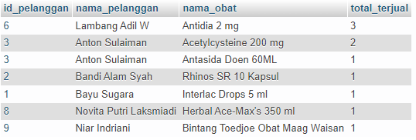

1. Menggabungkan Table Transaksi, Petugas, dan Obat

[SELECT](http://localhost/phpmyadmin/url.php?url=https://dev.mysql.com/doc/refman/8.0/en/select.html) id_petugas, nama_petugas, nama_obat, [SUM](http://localhost/phpmyadmin/url.php?url=https://dev.mysql.com/doc/refman/8.0/en/group-by-functions.html#function_sum)(jumlah_beli) as total FROM transaksi [LEFT](http://localhost/phpmyadmin/url.php?url=https://dev.mysql.com/doc/refman/8.0/en/string-functions.html#function_left) JOIN petugas ON transaksi.id_petugas = petugas.id [LEFT](http://localhost/phpmyadmin/url.php?url=https://dev.mysql.com/doc/refman/8.0/en/string-functions.html#function_left) JOIN obat ON transaksi.id_obat = obat.id GROUP BY id_petugas;

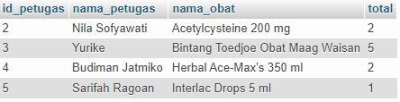

1. Menggabungkan Table Transaksi, Petugas, Pelanggan dan Obat.

[SELECT](http://localhost/phpmyadmin/url.php?url=https://dev.mysql.com/doc/refman/8.0/en/select.html) transaksi.id, nama_petugas, nama_pelanggan, nama_obat, [SUM](http://localhost/phpmyadmin/url.php?url=https://dev.mysql.com/doc/refman/8.0/en/group-by-functions.html#function_sum)(harga_beli) as total FROM transaksi [LEFT](http://localhost/phpmyadmin/url.php?url=https://dev.mysql.com/doc/refman/8.0/en/string-functions.html#function_left) JOIN petugas ON transaksi.id_petugas = petugas.id [LEFT](http://localhost/phpmyadmin/url.php?url=https://dev.mysql.com/doc/refman/8.0/en/string-functions.html#function_left) JOIN pelanggan ON transaksi.id_pelanggan = pelanggan.id [LEFT](http://localhost/phpmyadmin/url.php?url=https://dev.mysql.com/doc/refman/8.0/en/string-functions.html#function_left) JOIN obat ON transaksi.id_obat = obat.id GROUP BY transaksi.id;

